WORLD WAR 2
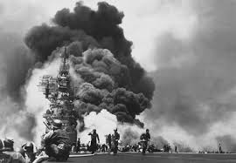Date - September 1, 1939 – September 2, 1945
Location - Europe, Pacific, Atlantic, South-East Asia, China, Middle East, Mediterranean and Africa
Results
- Allied victory
- Foundation of the United Nations
- The United States and the Soviet Union became superpowers.
- The empires of Italy, Japan, and Germany dissolved.

Participants
Allies
- United Kingdom
- Soviet Union (from 1941)
- United States (from 1941)
- Republic of China (from 1937)
- France (1939-40, 1944-45)
Axis
- Germany
- Japan (from 1937)
- Italy (from 1940)
- Commanders and leaders
Allied leaders
United Kingdom- Winston Churchill
Soviet Union- Joseph Stalin
United States- Franklin D. Roosevelt
Axis leaders
Nazi- Germany- Adolf Hitler
Kingdom of Italy (1861–1946)- Benito Mussolini
No: of Deaths
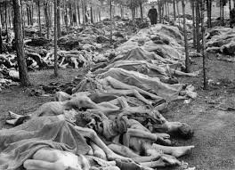
Military Dead::Over 16,000,000
Civilian Dead:Over 45,000,000
Total Dead:Over 61,000,000
Military Dead:Over 8,000,000
Civilian Dead:Over 4,000,000
Total Dead:Over 12,000,000
Note
World War II (WWII or WW2), also known as the Second World War, was a global war. It took place between 1939 to 1945. Most of the world's countries, including all of the great powers, fought as part of two military alliances: the Allies and the Axis. The war was fought as a "total war", meaning all resources a country had were used in the war, even those that didn't belong to the army, such as factories. It involved more countries, cost more money, and killed more people than any other war in human history. Between 50 and 70 million people died.The Holocaust and two atomic bombings of Japan are two important events that killed many civilians.

The start of the war is usually said to be the Invasion of Poland on September 1, 1939, but some sources count the Japanese invasion of China on July 7, 1937, as the start. The United States reacted to the Japanese invasion of China by placing an embargo on Japan. France, United Kingdom, and most of their colonies reacted to the German invasion of Poland by declaring war on Germany. Germany expanded its territory greatly in Europe. By 1941, most of Europe was under German control, while only Britain remained fighting against the Axis in North Africa, Mediterranean, and the Atlantic. In June 1941, the Axis Powers invaded the Soviet Union, starting the largest theatre of war in history. This would harm the Axis military power greatly. In December 1941, Japan attacked Western colonies in the Pacific.

The Japanese victories were stopped in 1942, and the European Axis victories were also stopped by 1943, both in North Africa and in the Soviet Union. After that, the Allies started to fight back from all sides. The Axis lost North Africa and, starting in 1943, were forced to defend Italy. In 1944, the Allies invaded France, heading towards Germany, while the Soviets kept closing in from the East. Germany surrendered in May 1945. Japan formally surrendered on September 2, 1945. The war ended with the Allied victory.

After the war, the United Nations was set up to develop support between countries and to prevent future wars. The Cold War took place between the two superpowers, the Soviet Union and the United States, but they did not fight each other in an actual war. Decolonization of Asia and Africa, where those countries controlled by European countries were given their independence, happened as well. This was because European power was weakened from the war. Economic recovery and the political integration (the process of uniting countries) were among other results of the war.
Added by
Thisal Kaushika

